If

|  |  |
| --- | --- |
| For ${\left(0+1\right)}^{*}$ | For $01$ |
|  |  |

Then to create the diagram for ${\left(0+1\right)}^{*}01$, we need to:

1. Introduce an Ɛ-transition from each of the final states in the left part of the RE (i.e., ${\left(0+1\right)}^{*}$) to the start state in the right part of the RE (i.e., $01$)
2. Turn all the final states in the left part of the RE (i.e., ${\left(0+1\right)}^{*}$) into non-final states

So, for ${\left(0+1\right)}^{*}01$ we would get:

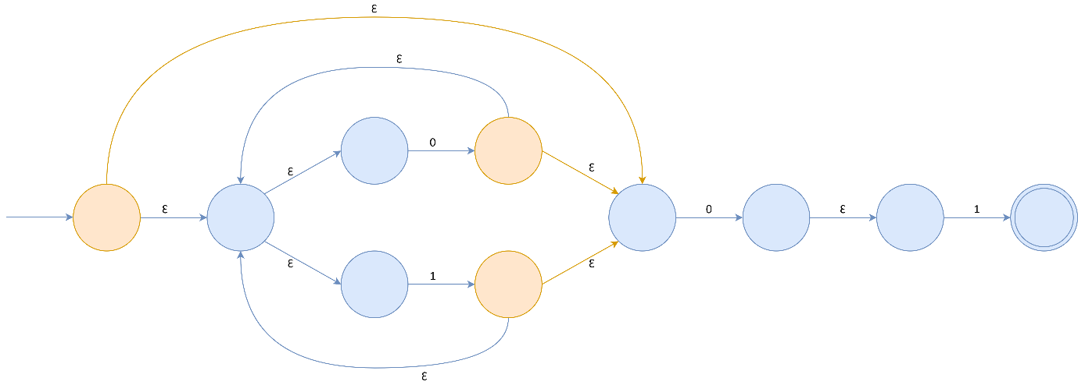

A common mistake that was observed was that none of you drew a transition from the starting state of ${\left(0+1\right)}^{*}$ which was also a final state nor did you convert it to a non-final state. Some of you managed to convert this state into non-final. But the transition wasn’t illustrated by anyone. The state in discussion along with the new Ɛ-transition from it is marked in red in the following figure.

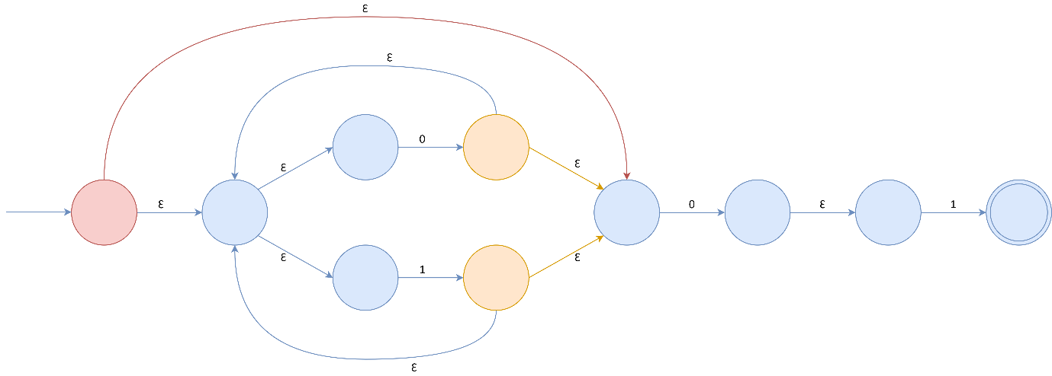

**N.B:** The REs were used for illustration purposes. These exact REs were not from the question paper.